Linked List

What is an Linked List?
# Source: AI Source: Provided by: [Data Path: Persons Table -> ID Column: 1, Name_En Column: Motasem Essam] -> From: [Chatgpt (GPT‑5 Mini)] on [12/10/2025]
A Linked List is a linear data structure where elements, called nodes, are not stored in contiguous memory locations.
Each node contains:
- Data – the value stored in the node
- Pointer/Next – a reference to the next node in the list
Linked lists are used when you need dynamic memory allocation and frequent insertion or deletion of elements.

Key Characteristics
# Source: AI Source: Provided by: [Data Path: Persons Table -> ID Column: 1, Name_En Column: Motasem Essam] -> From: [Chatgpt (GPT‑5 Mini)] on [12/10/2025]
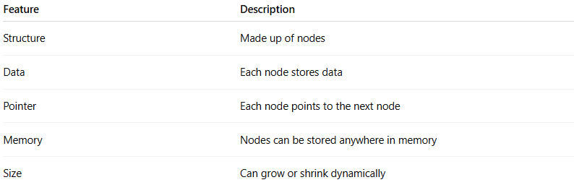
Feature | Description
Structure | Made up of nodes
Data | Each node stores data
Pointer | Each node points to the next node
Memory | Nodes can be stored anywhere in memory
Size | Can grow or shrink dynamically

Types of Linked Lists
- Singly Linked List
- Each node points to the next node only.
- Traversal is possible in one direction.
- Example:
Head -> 10 -> 20 -> 30 -> NULL
- Doubly Linked List
- Each node points to both next and previous nodes.
- Traversal is possible in both directions.
- Example:
NULL <- 10 <-> 20 <-> 30 -> NULL
- Circular Linked List
- Last node points back to the first node, forming a circle.
- Can be singly or doubly linked.
- Example (singly circular):
Head -> 10 -> 20 -> 30 -> Head

Example of a Singly Linked List
# Source: AI Source: Provided by: [Data Path: Persons Table -> ID Column: 1, Name_En Column: Motasem Essam] -> From: [Chatgpt (GPT‑5 Mini)] on [12/10/2025]
Head -> 10 -> 20 -> 30 -> 40 -> NULL
- Head – starting node
- NULL – indicates the end of the list

Example in C (Singly Linked List Node)
# Source: AI Source: Provided by: [Data Path: Persons Table -> ID Column: 1, Name_En Column: Motasem Essam] -> From: [Chatgpt (GPT‑5 Mini)] on [12/10/2025]
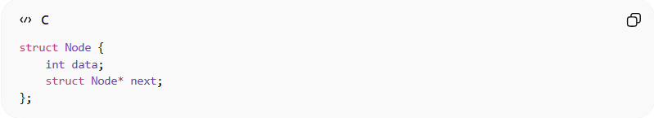
struct Node {
int data;
struct Node* next;
};
Creating a node:
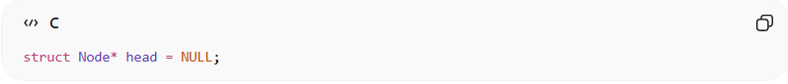
struct Node* head = NULL;

Common Operations on Linked Lists
# Source: AI Source: Provided by: [Data Path: Persons Table -> ID Column: 1, Name_En Column: Motasem Essam] -> From: [Chatgpt (GPT‑5 Mini)] on [12/10/2025]

1. Access (Reading an Element)
# Source: AI Source: Provided by: [Data Path: Persons Table -> ID Column: 1, Name_En Column: Motasem Essam] -> From: [Chatgpt (GPT‑5 Mini)] on [12/10/2025]
Definition:
Accessing means retrieving a specific node from the linked list using its position (index).
Unlike arrays, linked lists do not allow direct access by index. To access a node, you must start at the head and traverse nodes one by one until the desired position.
Example Linked List:
Head -> 10 -> 20 -> 30 -> 40 -> NULL
Accessing node at position 2:
- Start at head → 10
- Move to next → 20
- Move to next → 30
Example in C:
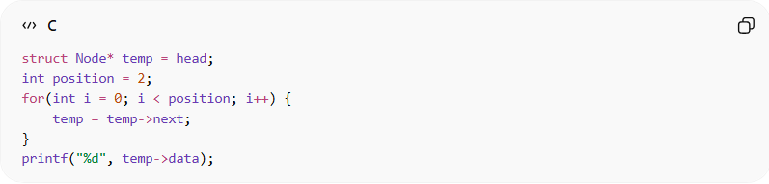
struct Node* temp = head;
int position = 2;
for(int i = 0; i < position; i++) {
temp = temp->next;
}
printf("%d", temp->data);
Output:
30
Access Time Complexity:
- Time Complexity: O(n)
- Reason: Must traverse from the head to the desired node since there is no direct indexing.

2. Insertion (Adding a Node)
# Source: AI Source: Provided by: [Data Path: Persons Table -> ID Column: 1, Name_En Column: Motasem Essam] -> From: [Chatgpt (GPT‑5 Mini)] on [12/10/2025]
Definition:
Insertion means adding a new node at the beginning, end, or a specific position in the list.
Example Linked List:
Head -> 10 -> 20 -> 30 -> NULL
Insert 25 at position 2:
Step 1 – Traverse to position 1:
Head -> 10 -> 20 -> 30 -> NULL
Step 2 – Adjust pointers:
Head -> 10 -> 25 -> 20 -> 30 -> NULL
Example in C (Insertion at position 2):
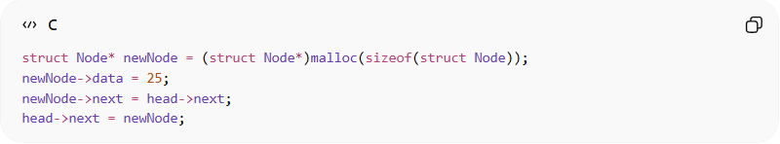
struct Node* newNode = (struct Node*)malloc(sizeof(struct Node));
newNode->data = 25;
newNode->next = head->next;
head->next = newNode;

Insertion Time Complexity:
- Time Complexity:
  - At beginning: O(1)
  - At position or end: O(n)
- Reason: Must traverse to the desired position before inserting, except at the head.

3. Deletion (Removing a Node)
# Source: AI Source: Provided by: [Data Path: Persons Table -> ID Column: 1, Name_En Column: Motasem Essam] -> From: [Chatgpt (GPT‑5 Mini)] on [12/10/2025]
Definition:
Deletion removes a node from the beginning, end, or a specific position.
Example Linked List:
Head -> 10 -> 25 -> 20 -> 30 -> NULL
Delete node at position 2 (25):
Step 1 – Traverse to position 1:
Head -> 10 -> 25 -> 20 -> 30 -> NULL
Step 2 – Adjust pointers:
Head -> 10 -> 20 -> 30 -> NULL
Example in C (Deletion at position 2):
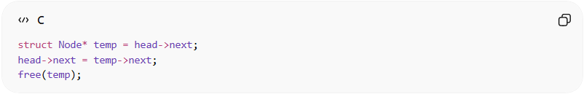
struct Node* temp = head->next;
head->next = temp->next;
free(temp);
Deletion Time Complexity:
Time Complexity:
- At beginning: O(1)
- At position or end: O(n)
Reason: Must traverse to the previous node to adjust pointers before deletion, except at the head.

4. Traversal (Visiting All Nodes)
# Source: AI Source: Provided by: [Data Path: Persons Table -> ID Column: 1, Name_En Column: Motasem Essam] -> From: [Chatgpt (GPT‑5 Mini)] on [12/10/2025]
Definition:
Traversal means visiting each node in the linked list one by one.
It is often used to:
- Print values
- Calculate totals
- Modify nodes
Example Linked List:
Head -> 10 -> 20 -> 30 -> 40 -> NULL
Traversal prints:
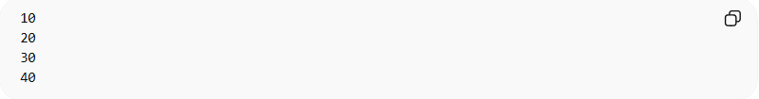
10
20
30
40
Example in C:
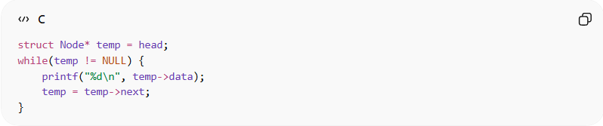
struct Node* temp = head;
while(temp != NULL) {
printf("%d\n", temp->data);
temp = temp->next;
}
Traversal Time Complexity:
- Time Complexity: O(n)
- Reason: Must visit every node starting from the head.

5. Searching (Finding a Node)
# Source: AI Source: Provided by: [Data Path: Persons Table -> ID Column: 1, Name_En Column: Motasem Essam] -> From: [Chatgpt (GPT‑5 Mini)] on [12/10/2025]
Definition:
Searching means finding the position of a node containing a specific value in the linked list.
Example Linked List:
Head -> 10 -> 20 -> 30 -> 40 -> NULL
Search for value 30 → Position = 2
Example in C (Linear Search):
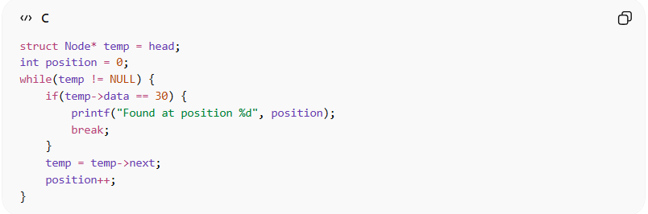
struct Node* temp = head;
int position = 0;
while(temp != NULL) {
if(temp->data == 30) {
printf("Found at position %d", position);
break;
}
temp = temp->next;
position++;
}
Searching Time Complexity:
- Time Complexity: O(n)
- Reason: Must check each node until the target value is found.

Summary of Linked List Operations
# Source: AI Source: Provided by: [Data Path: Persons Table -> ID Column: 1, Name_En Column: Motasem Essam] -> From: [Chatgpt (GPT‑5 Mini)] on [12/10/2025]
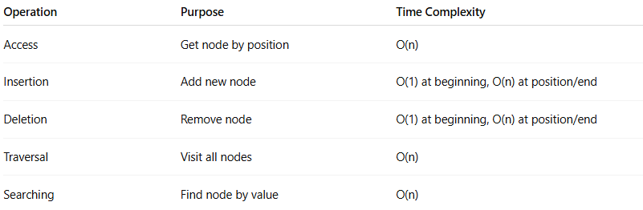
Operation | Purpose | Time Complexity
Access | Get node by position | O(n)
Insertion | Add new node | O(1) at beginning, O(n) at position/end
Deletion | Remove node | O(1) at beginning, O(n) at position/end
Traversal | Visit all nodes | O(n)
Searching | Find node by value | O(n)

Real-World Examples
# Source: AI Source: Provided by: [Data Path: Persons Table -> ID Column: 1, Name_En Column: Motasem Essam] -> From: [Chatgpt (GPT‑5 Mini)] on [12/10/2025]

Example | Description
Music playlist | Songs linked in order, can add/remove easily
Browser history | Each page links to the next visited page
Undo feature | Actions linked in sequence for undo operations

Advantages of Linked Lists
# Source: AI Source: Provided by: [Data Path: Persons Table -> ID Column: 1, Name_En Column: Motasem Essam] -> From: [Chatgpt (GPT‑5 Mini)] on [12/10/2025]
- Dynamic size (can grow or shrink as needed)
- Easy insertion and deletion compared to arrays
- Efficient memory usage for unknown data size

Disadvantages of Linked Lists
# Source: AI Source: Provided by: [Data Path: Persons Table -> ID Column: 1, Name_En Column: Motasem Essam] -> From: [Chatgpt (GPT‑5 Mini)] on [12/10/2025]
- No direct access by index (slower than arrays)
- Extra memory needed for storing pointers
- Traversal can be slower due to pointer chasing

